**SQL Assignments:**

1. **Write a query to display the columns in a specific order, such as order date, salesman ID, order number, and purchase amount for all orders.**

create table sales_data

(

ord_no int,

purchase_amt float,

ord_date date,

cust_id int,

salesman_id int

)

insert into sales_data values(70001, 150.5, "2012-10-05", 3005, 5002

);

insert into sales_data values(70009, 270.65 ,"2012-09-10" ,3001 ,5005);

insert into sales_data values(70009, 270.65 ,"2012-09-10" ,3001 ,5005);

insert into sales_data values(70009, 270.65 ,"2012-09-10" ,3001 ,5005

);

insert into sales_data values(70002, 65.26, "2012-10-05" ,3002, 5001

);

insert into sales_data values(70004 ,110.5 ,"2012-08-17" ,3009 ,5003

);

insert into sales_data values(70007, 948.5, "2012-09-10" ,3005 ,5002

);

insert into sales_data values(70005, 2400.6, "2012-07-27" ,3007, 5001

);

insert into sales_data values(70008 ,5760 ,"2012-09-10" ,3002 ,5001

);

insert into sales_data values(70010 ,1983.43, "2012-10-10", 3004, 5006

);

insert into sales_data values(70003 ,2480.4, "2012-10-10" ,3009 ,5003

);

insert into sales_data values(70012 ,250.45, "2012-06-27", 3008 ,5002

);

insert into sales_data values(70011 ,75.29, "2012-08-17" ,3003 ,5007

);

insert into sales_data values(70013 ,3045.6, "2012-04-25", 3002, 5001

);

select ord_date,

salesman_id, ord_no, purchase_amt

from sales_data;

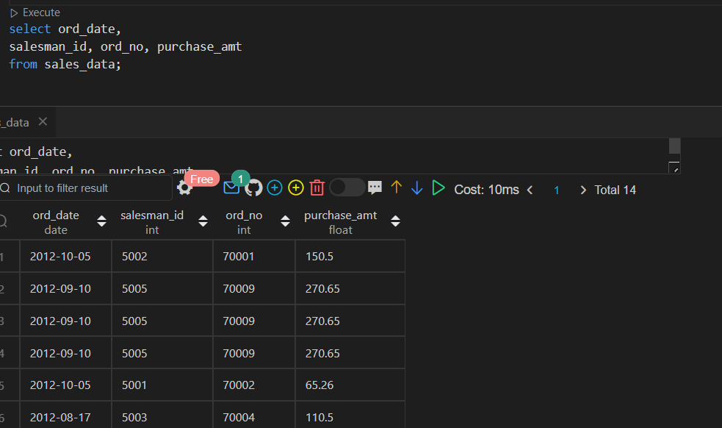

1. **From the following table, write a SQL query to locate salespeople who live in the city of 'Paris'. Return salesperson's name, city.**

create table sales_city

(

salesman_id int,

name varchar(100),

city varchar(100),

commission float

);

insert into sales_city values(5001,"James Hoog","New York",0.15);

insert into sales_city values(5002,'Nail Knite','Paris',0.13);

insert into sales_city values(5005,'Pit Alex','London',0.11);

insert into sales_city values(5006,'Mc Lyon','Paris',0.14);

insert into sales_city values(5007,'Paul Adam','Rome',0.13);

insert into sales_city values(5003,'Lauson Hen','San Jose',0.12);

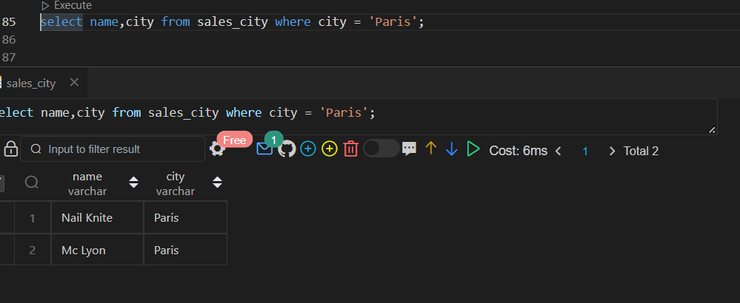

1. From the following table, write a SQL query to select a range of products whose price is in the range Rs.200 to Rs.600. Begin and end values are included. Return pro_id, pro_name, pro_price, and pro_com.
2. create table products
3. (
4. pro_id int,
5. pro_name varchar(50),
6. pro_price float,
7. pro_com int
8. );
9. insert into products values (101,'Motherboard',3200.00,15);
10. insert into products values (102,'KeyBoard',450.00,16);
11. insert into products values (103,"ZIP drive",250.00,14);
12. insert into products values (104,'Speaker',550.00,16);
13. insert into products values (105,'Monitor',5000.00,11);
14. insert into products values (106,'DVD Drive',900.00,12);
15. insert into products values(107,'CD Drive',800.00,12);
16. insert into products values(108,'Printer',2600.00,13);
17. insert into products values(109,'Refil Catridge',350.00,13);
18. insert into products values(110,'Mouse',250.00,12);

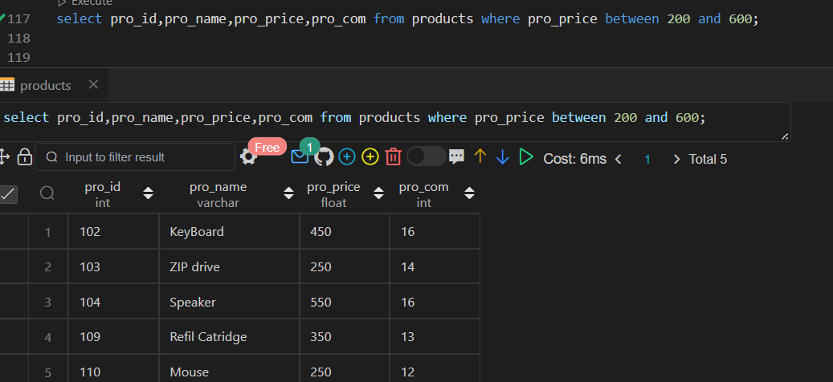

**4. From the following table, write a SQL query to find the items whose prices are higher than or equal to $550. Order the result by product price in descending, then product name in ascending.**

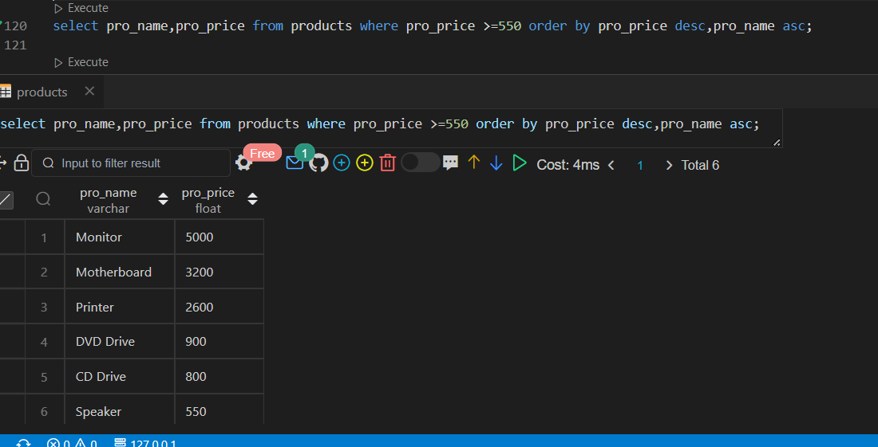

**5. From the following table, write a SQL query to find details of all orders excluding those with ord_date equal to '2012-09-10' and salesman_id higher than 5005 or purch_amt greater than 1000.Return ord_no, purch_amt, ord_date, customer_id and salesman_id.**

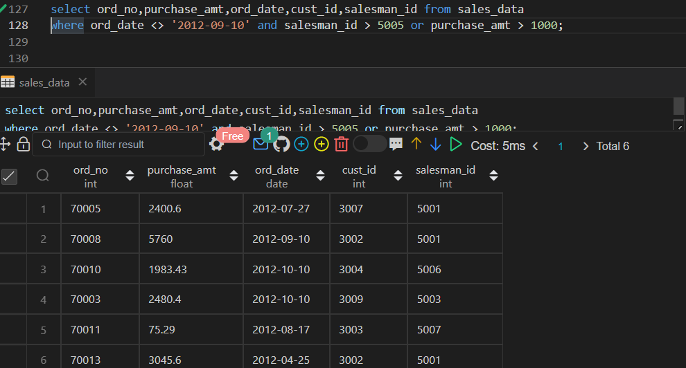

**6. Create the table world with your schema and find the below queries !**

1. Write a query to fetch which country has the highest population?

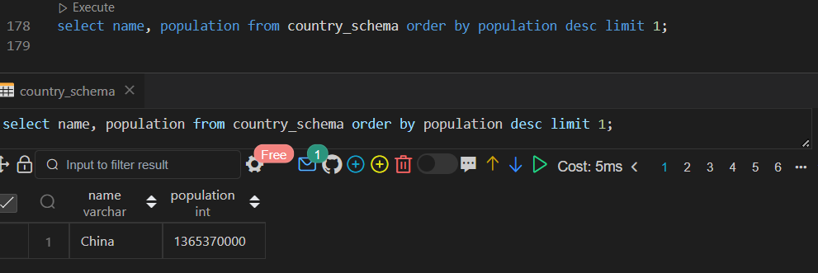

1. write a query to fetch the name of the country which has the least gdp?

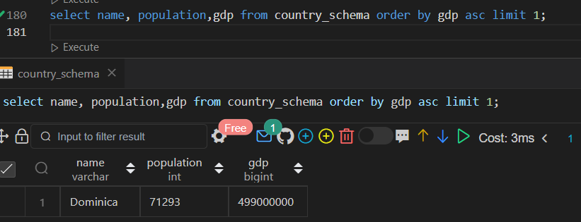

1. Write a query to fetch the name of the country which ends with letter C?

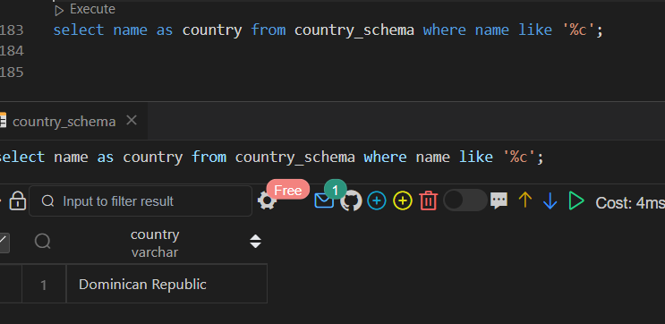

1. write a query to fetch the name of the country which starts with letter D?

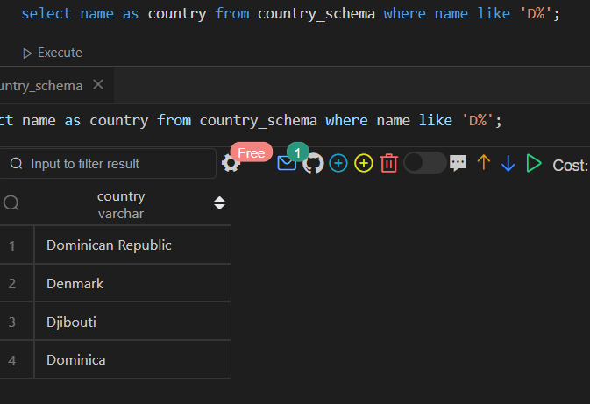

1. write query to fetch which continent has highest gdp?

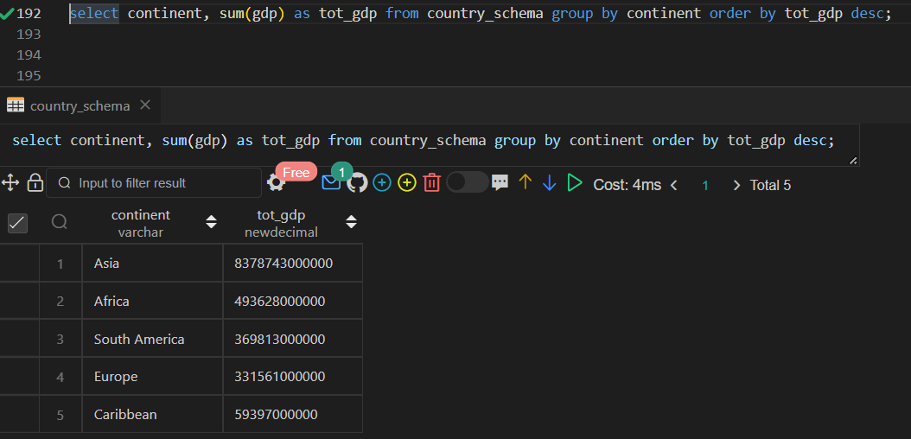

1. Give the total GDP of Africa?

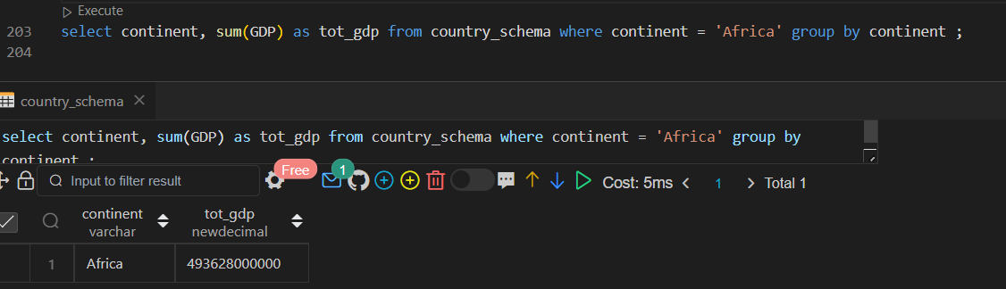

1. write a query to fetch the total population for each continent?

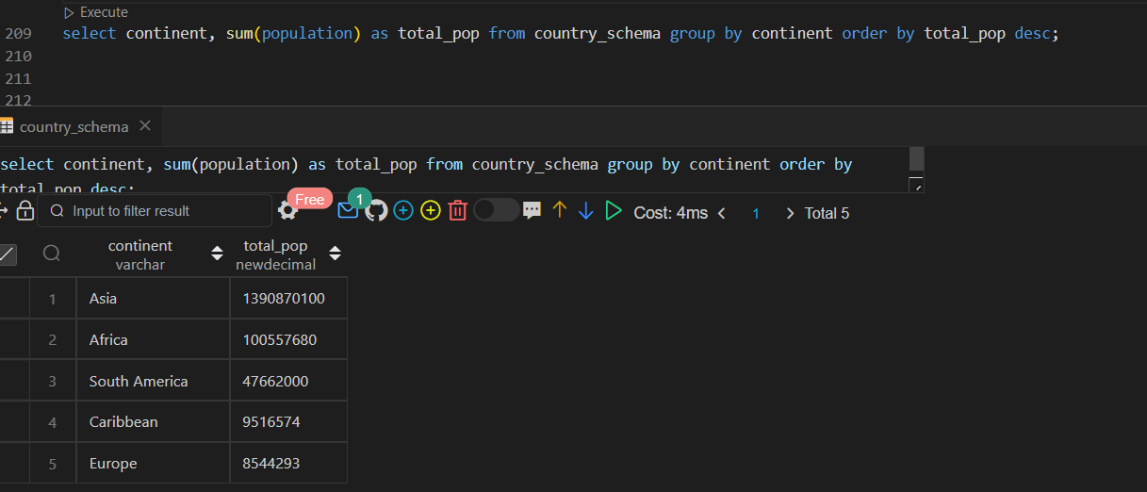

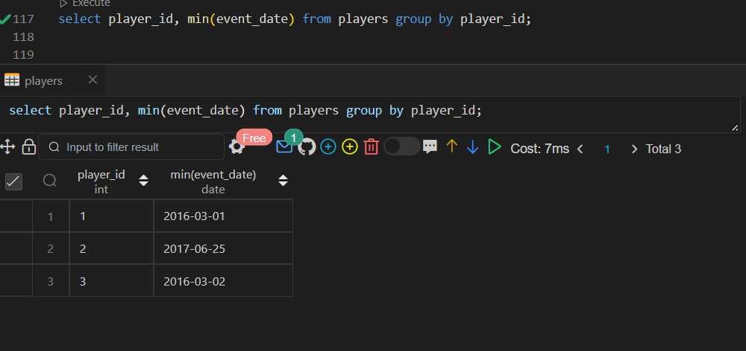

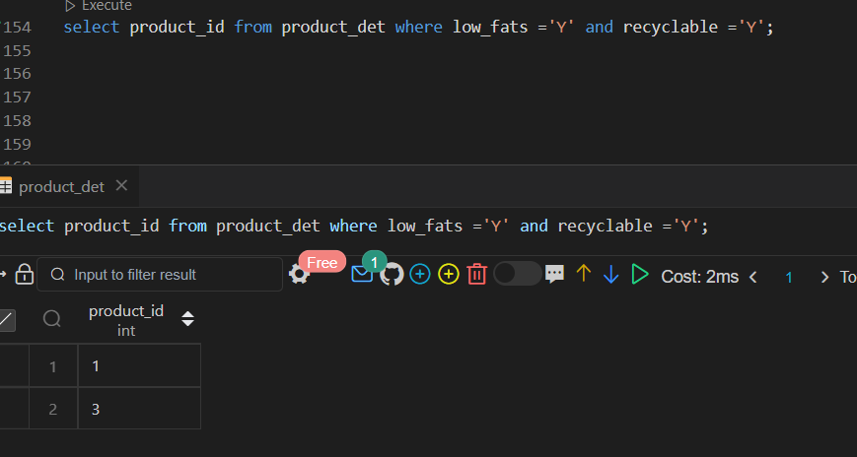

1. A.

. Select the statement that shows the sum of population of all countries i

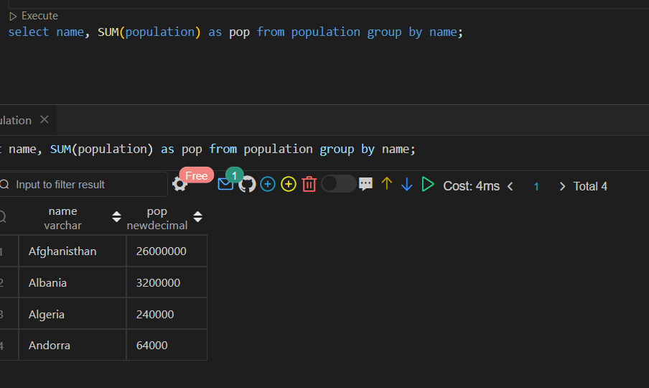

b. Select the statement that shows the number of countries with population smaller than 150000

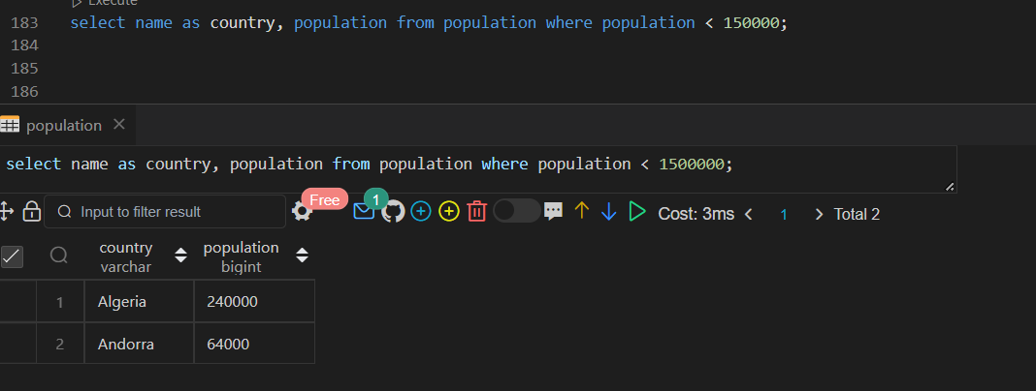

c. Select the list of core SQL aggregate functions.

select name as country, avg(gdp) from population where gdp is not null group by country;

select name , sum(population) as totalpop from population group by name;

select name, population as pop from population order by population desc;

select name, count(population) from population group by name;

select  name, min(population) from population group by name;

select  name, max(population) from population group by name;

d. Select the statement that shows the average population of 'Poland', 'Germany' and 'Denmark'

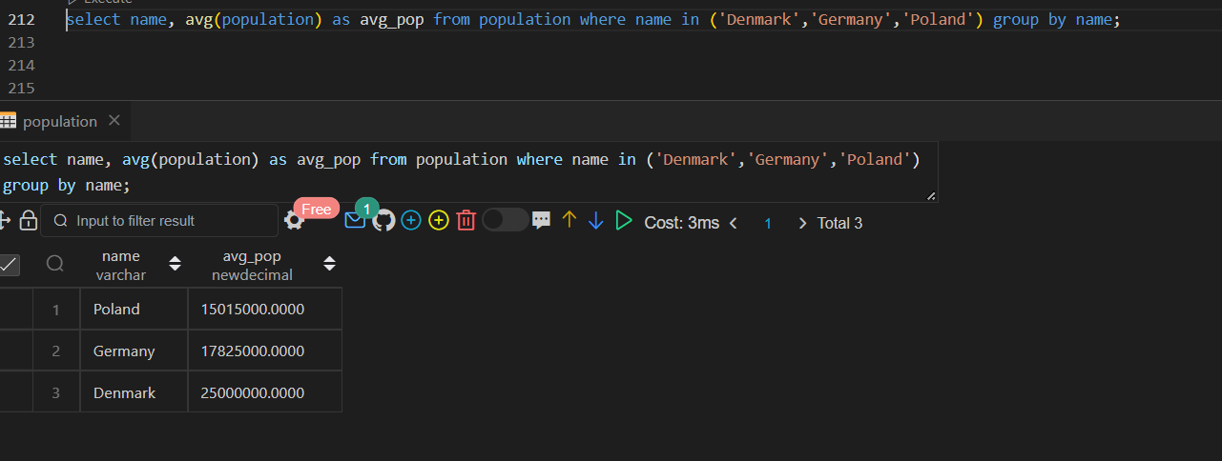

e. Select the statement that shows the medium population density of each region

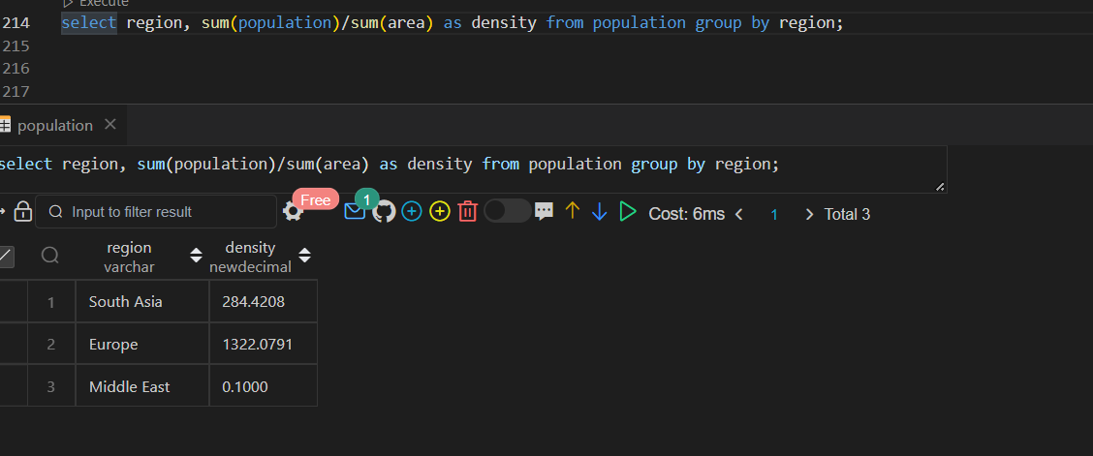

f. Select the statement that shows the name and population density of the country with the largest population.

